1Fintech

F 6 - Kinh Đo Tower, 292 Tay Son st., Hà Noi

 | Tel: 08 66.79.83.87 | Hotline: 1900.6946
 |  | Email: contact@1fintech.com

SMS BRANDING API FOR

AGENT DOCUMENT

Table of Contents

1. System overview 3

2. WorkFlow 3

3. MO side 5

4. MT side 5

1. System Overview

SMS Gateway is the two-way interactive SMS gateway between the enterprise and the end-users through mobile devices.

The SMS gateway is connected directly to 5 telcos in Vietnam, include: Mobifone, Vinaphone, Viettel, Vietnammobile and Gtel.

2. WorkFlow
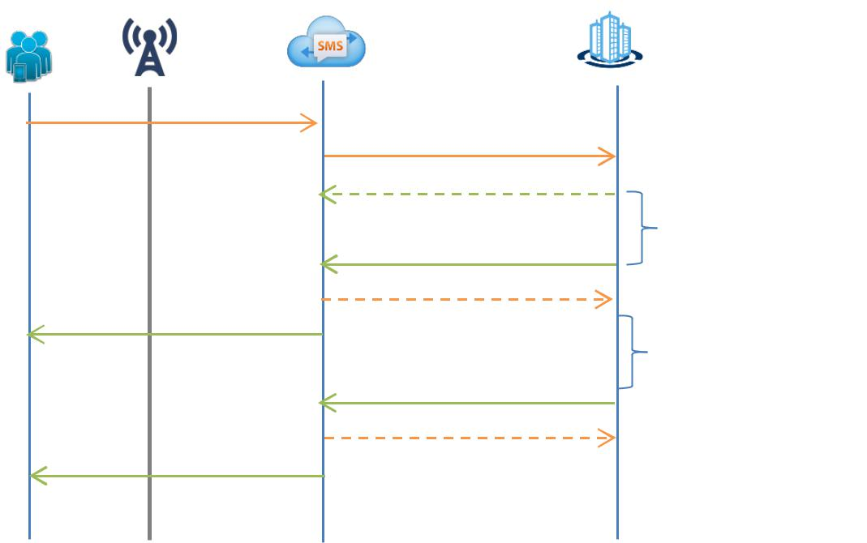

MO

MO

ACK

MT
ACK

MT

MO processing

MT
ACK

MT

End-User |  |  |  |  |  | Content Provider
End-User |  | Telcos |  | 1Fintech Gateway |  | Content Provider

• MO: Mobile Originated
• MT: Mobile Terminated

WS address: http://sms.1fintech.vn/api/MOMTsms

Description:

 MO side

- Step 1: End-user send a message to 8x88 with the message syntax has been defined.

- Step 2: Telcos send MO to the 1 Fintech SMS gateway.

- Step 3: 1Fintech SMS gateway system send MO to the CP.

- If the process is successful, the SMS gateway system will save the MO.

    - If the process is unsuccessful, the SMS gateway system will automatically send back the MO after a preset time.

- Step 4: CP system performs logical processing according to the MO contents received. Finish MO side.

  - MT side

- Step 1: CP system creates the MT contents that should be returned to the end-user and transfer to the 1Fintech SMS gateway system.

- Step 2: 1Fintech SMS gateway receive the MT contents and send to Telcos.

- If the process is successful, the SMS gateway system will save the MT.

- If the process is unsuccessful, the SMS gateway system will automatically send back the MT after a preset time.
- Step 3: Telcos send the MT to the end-user. Finish the MT side.

Requiring Connection :

For 1Fintech SMS gateway system send the MO to the CP system, CP should provide the information:
- Api endpoint receives MO

For CP system send the MT to the 1Fintech SMS gateway system:
- CP will be provided with the following information:
- CP information (partnerCode & partnerKey)

- Api endpoint receives MT
- CP need to provide the IP address request API of 1Fintech (because 1Fintech will filter IP address)

- Notice:

  - CP can send multiple MT contents to a coresponding MO.

  - CP isn’t allowes to send MT without MO.

  - All the MO has the same (requestID) counted as a single MO.

3. MO side

- Function: receiveMO

- Type: String

- Protocol: Restful

- Ex: : >= 0 (success) <0 (Fail)

Parameter:
Parameter | Type | Require | Description
Partner_code | String | Yes | The partner code provided by 1Fintech
User_id | String | Yes | The telephone number of end-user
Service_id | String | Yes | Message code (Ex: 8100, 8200,..)
Command_code | String | Yes | Service code (Ex: 1Fintech …)
Message | String | Yes | The customer’s message content send to the operator
Request_id | String | Yes | The messager numerical order has created automatically by the system

4. MT side

- Function: sendMT

- Type: String

- Protocol: Restful

- Ex: 0 (success) or error code

Parameter:

Parameter | Type | Require | Description
Partner_code | String | Yes | The partner code provided by 1Fintech
User_id | String | Yes | The telephone number of end user
Message | String | Yes | The MT contents (Notice: The characters in the MT content in the first 128 characters of ASCII and not using Vietnamese characters
Service_id | String | Yes | Message code (Ex: 8100,8200…)
Command_code | String | Yes | Service code (Ex: VCB NAP …)
Request_id | String | Yes | Coresponding to request_id MO
Message_index | Number | Yes | The number of message (Ex: 1-the first message;  2-The second message…)
Mt_end | Number | Yes | The last MT ( Ex: 0 – the last MT; 1 – Having the next message…)
Total_message | Number | No | The total number of messages will be grouped into an MT to respond to this MO
Content_type | Number | Yes | The type of message send to the end-users (0:text; 1:ringtone; 2:logo; 3:picture message)
Reference_id | Number | Yes | Reference_id of CP
Signature | String | Yes | Signature MD5 (plaintext)

Signature: Md5 Encoding plaintext string format “partner_code|User_id|Message|Service_id|Command_code|Request_id|Reference_Id|secretKey”
SecretKey: The secret code provided by 1Fintech.

Error code:
Code | Description
-1 | The Partner_code does not exist
-2 | The Partner_code does not activated
-3 | The IP address does not inform
-4 | Request_id doesn’t exist
-5 | Invalid phone number
-6 | Invalid service_id
-7 | Invalid command code
-8 | MT is stopped ( incase of having the last MT but still sending the MT)
-9 | Wrong number of MT
-10 | Over quota of MT
-11 | Exceeds the prescribed time of Telcos
-12 | Duplicate MT
-100 | Other error

